# How loud is a string?

## Introduction

I enjoy playing songs on piano. However, I have noticed that while it is easy to play louder sound, playing quietly have always been a challenge. This turned me curious of the relationship between the loudness of the sound and the amount of force that I apply to it.

## Experiment

### Design

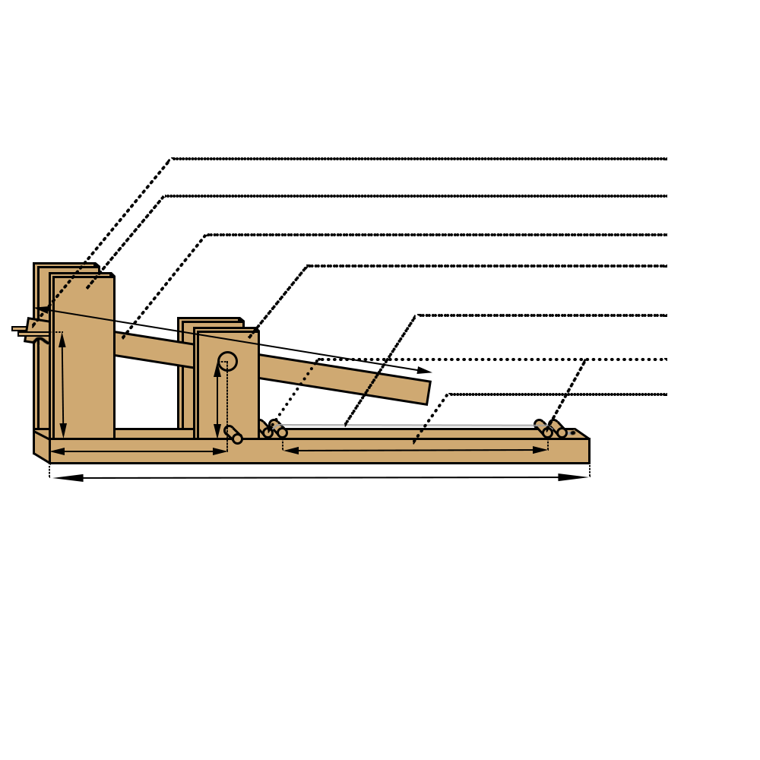

Back Board

Pressure rod

String

First Shelf

Lever

Second shelf

Rubber band holder

### Controlled Variables

|  |  |  |
| --- | --- | --- |
| ­­­Name | significance | control |
| Tension and length of the string | The amplitude of the displacement of the center of the string is dependent on the length of the string and the tension force in the string. An increase in either tension or length of the string will decrease the amplitude of vibration. | I tied the string onto a knob which is in the structure. The knob’s friction holds the tension and length of the string constant, and it also enables me to adjust the string if it has gotten loose. There is a mark on the knob which matches up with another knob on the structure to help during adjustment |
| Striking point on the string | The mathematical model which I built requires that the striking force is applied at the center of the string. If the striking force is not applied at the center, the angle change of the two ends of the string would be different, which will cause my math model to fail. | I built a lever to strike the string in order to solve this issue. With this structure, it makes sure that every time the striking force is applied at the center of the string. |
| Gain of the microphone | The gain of the microphone will directly affect the output voltage of the microphone, because the output voltage if the microphone can be manipulated by the gain of the microphone. A compensation can be made if value is not kept constant by recording the gain of each recording and doing different calculations for each trial. | The microphone that I used have a knob to adjust the level of gain of the microphone. The gain is turned to the lowest which the microphone support, because this allows the greatest range of recording without any disturbance: disturbance occur when the amplified sound from gain is louder than the maximum recording loudness of the mic. |
| Stability of the two ends of the string | Movement at the ends of the string will cause energy loss in the system, which takes away power from the sound produces. This causes the intensity (loudness) of the sound to decrease | Two sticks were added on each of the ends of the string: one to apply pressure on the string to minimize movement, other one to levitate the string above backboard to give space for the jack to produce the amplitude. |
| Loudness of the room | Sound in the room which the experiment is conducted will increase the measured intensity of the sound, which will cause inaccuracy in the result of the experiment. | I went to a separate small room to record the audio with minimal background noise. |

### Procedure

## Hypothesis

### Variables

|  |  |  |
| --- | --- | --- |
| Variable | Meaning | Unit |
| $$I$$ | Intensity | $$W/{m^{2}}$$ |
| $$p$$ | Sound pressure | $$Pa$$ |
| $$v$$ | Particle velocity | $$m/s$$ |
| $$ω$$ | Angular frequency | $${rad}/s$$ |
| $$a$$ | Amplitude (particle displacement) | $$m$$ |
| $$μ$$ | Density of medium in which sound is traveling | $${kg}/{m^{3}}$$ |
| $$c$$ | Speed of wave (sound) | $$m/s$$ |
| $$f$$ | frequency | $$Hz$$ |
| $$π$$ | Ratio of circumference to diameter of a circle |  |
| $$F_{t1}$$ | Original tension of the string | $$N$$ |
| $$F_{t2}$$ | Tension of the string at equilibrium | $$N$$ |
| $$F_{a}$$ | Force of the striking object | $$N$$ |
| $$F_{v}$$ | Vertical component of the tension of the string | $$N$$ |
| $$x$$ | Change in length of the string after tension is applied | $$m$$ |
| $$k$$ | Spring constant of the string | $$N/m$$ |
| $$l_{o}$$ | Original length of the string | $$m$$ |
| $$l_{n}$$ | Current length of the string | $$m$$ |
| $$P_{no gain}$$ | Power output of the microphone without gain | $$V$$ |
| $$σ$$ | Sensitivity of the microphone | $$V/{Pa}$$ |
| $$P_{output}$$ | Actual output voltage of the microphone | $$V$$ |
| $$γ$$ | Gain of the microphone | $$V$$ |
| $$P_{dBV}$$ | Measured output of microphone | $$V$$ |

### Deriving the formula

The loudness of sound is determined by its intensity, which can be expressed as: $I=pv=\frac{1}{2}ω^{2}a^{2}μc$

Since angular frequency is just change in angle per second: ,

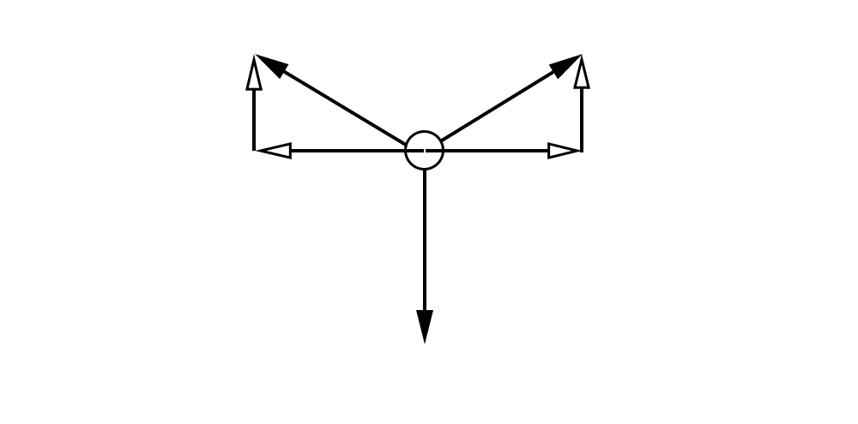

The amplitude is related to the tension force and the force pushing the string

Since at the maximum displacement, the system would be in equilibrium,

${2F}_{v}=F_{a}$, which means that $F_{t2}=\sqrt{{F_{t1}}^{2}-{(\frac{F_{a}}{2})}^{2}}$

Since $F_{t2}$ will be the final force on the string, the string will extend $x=\frac{F_{t2}}{k}=\frac{\sqrt{{F_{t1}}^{2}-{(\frac{F_{a}}{2})}^{2}}}{k}$ m

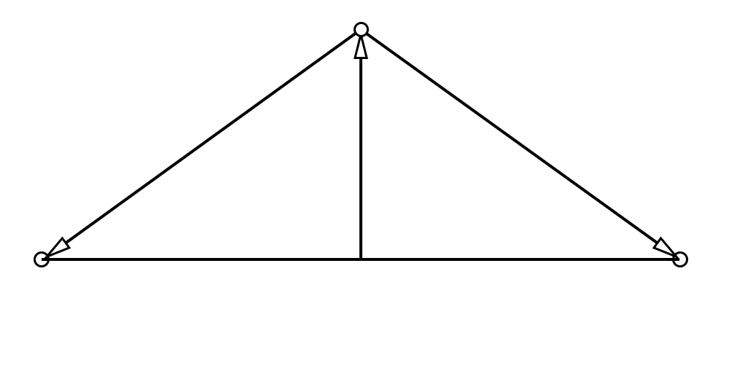

=>

Therefore $I={2π^{2}f^{2}a}^{2}μc={2π^{2}f^{2}\sqrt{({\frac{l_{o}}{2})}^{2}+{(\frac{l_{o}k+\sqrt{{F_{t1}}^{2}-{\left(\frac{F_{a}}{2}\right)}^{2}}}{2k})}^{2}}}^{2}μc=2π^{2}f^{2}[({\frac{l_{o}}{2})}^{2}+{\left(\frac{l_{o}k+\sqrt{{F_{t1}}^{2}-{\left(\frac{F_{a}}{2}\right)}^{2}}}{2k}\right)}^{2}]μc$

The sound pressure level can be determined by the power that the microphone produced divided by the sensitivity

$$p=\frac{P_{no gain}}{σ}=\frac{\frac{P_{output}}{γ}}{σ}=\frac{P_{output}}{γσ}$$

Also, as the measured power is in decibel $P_{dBV}=10log⁡(\frac{P_{output}}{1})$ => $P_{output}={10}^{\frac{P_{dBV}}{10}}$

As $v=ωa=2πfa$, therefore: $I=pv={10}^{\frac{P_{dBV}}{10}}∙2πfa$

Now, equal the two equations for intensity: $2π^{2}f^{2}\left[({\frac{l_{o}}{2})}^{2}+{\left(\frac{l_{o}k+\sqrt{{F_{t1}}^{2}-{\left(\frac{F_{a}}{2}\right)}^{2}}}{2k}\right)}^{2}\right]μc={10}^{\frac{P_{dBV}}{10}}∙2πfa$

And the equation can be simplified to: $πf\sqrt{{\frac{l_{o}}{2})}^{2}+{\left(\frac{l_{o}k+\sqrt{{F_{t1}}^{2}-{\left(\frac{F_{a}}{2}\right)}^{2}}}{2k}\right)}^{2}}μc={10}^{\frac{P_{dBV}}{10}}$

## Data

### Raw Data

### (uncertainty)

### Graph

### Summary

## Analysis

## Evaluation

### Safety

### Sources of error

## Conclusion